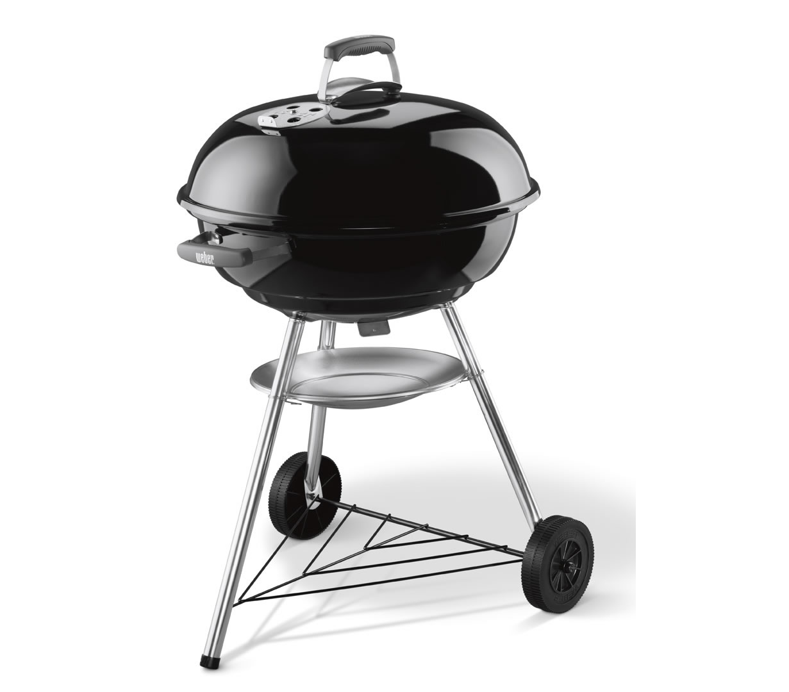

Database

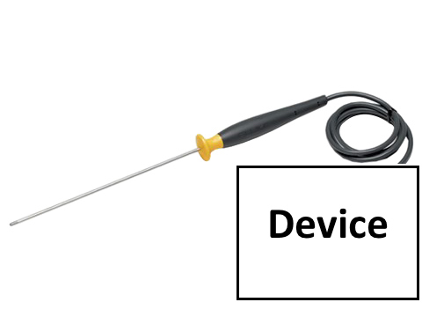

Temperature readings taken by device

Device sends data to database stored in the cloud

App receives data from the database.

App analyses the data and tells the user what is to be done

